Appendix 5

Detailed flow chart of selection of active antidepressant arms.

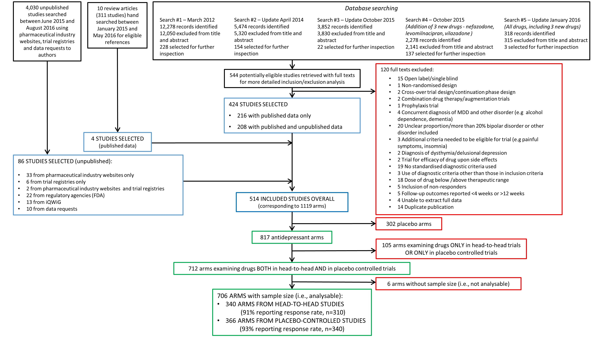
Black boxes present screened data, blue boxes present selected studies, green boxed present selected arms and red boxes present excluded studies or arms.

