Appendix 8

Results from multivariate meta-regression model including only the drugs as covariates.

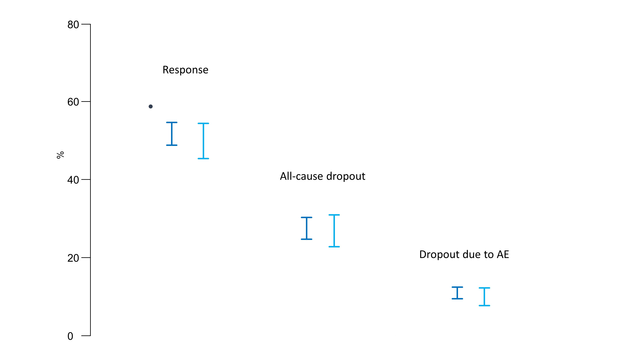

Circles represent assumed average response to antidepressants (59%), all-cause dropout (23%) and dropout due to adverse events (10%) estimated from arms with π=0%. In dark blue we present the 95% confidence intervals for response and dropout rates from arms with 0%<π<50% and in light blue from arms with π=50%. Confidence intervals are estimated by multiplying the assumed event rate in π=0% with the relative risks presented in Table 3.

