Tables
Table 1: Focus group participant demographics
Participant characteristics |  | Patients (n=7) | Family members (n=3) | Primary care health professionals (n=6) | Secondary care health professionals (n=5) | Total participants (n=21)
Age (years) | 18-39 | 0 | 0 | 1 | 2 | 3
 | 40-59 | 0 | 0 | 2 | 2 | 4
 | 60-79 | 5 | 2 | - | - | 7
 | 80+ | 2 | 1 | 0 | 0 | 3
Ethnicity | White | 7 | 3 | 5 | 5 | 20
 | Asian | 0 | 0 | 1 | 0 | 1
Sex | Male | 3 | 2 | 3 | 1 | 9
 | Female | 4 | 1 | 3 | 4 | 12
Cancer type | Non-small cell | 2
 | Not known | 5
Treatment type | Chemo and radiotherapy | 1
 | Chemo and surgery | 2
 | Surgery | 4
Clinical role | General practitioner |  |  | 5 | 0 | 5
 | Practice Manager |  |  | 1 | 0 | 1
 | Lung cancer nurse specialist |  |  | 0 | 4 | 4
 | Physiotherapist |  |  | 0 | 1 | 1
Years in healthcare profession | 1-5 |  |  | 1 | - | 0
 | 6-10 |  |  | 1 | 2 | 3
 | 11-15 |  |  | - | - | 0
 | >15 |  |  | 1 | 2 | 3

Table 2: Core sections of iEXHALE (prototype 1)
Section | Content | Screenshot
Introduction | Information about lung cancer and its treatment, common symptoms of fatigue, breathlessness and depression, and benefits of exercise for improving symptoms. | 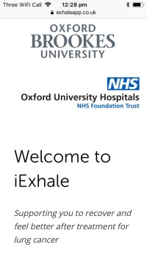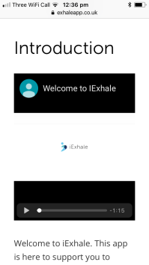
Self-rating symptoms | Users rate symptom severity, preferred activity level, and preferences for group/individual exercise activities. This information is used to generate three recommended exercises. | 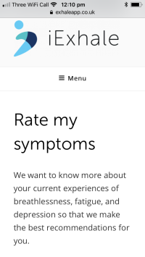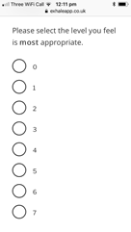
Exercise information | Users are provided with further information about three recommended exercises. Including information about how to access these exercise and, where necessary, video demonstrations on how to complete these. | 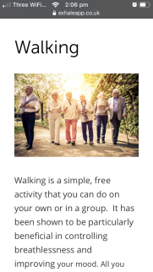
Self-monitoring diaries | Participants rate their current symptoms and indicate how often they have undertaken recommended exercise activities each week (type, duration, subjective rating). Email reminders sent to participants. | 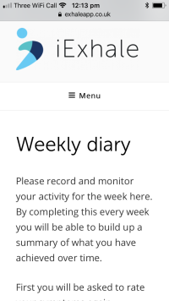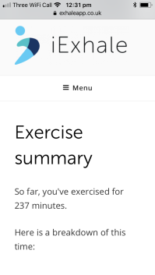

Table 3: Participant demographics and usability metrics
Demographics | UX1 | UX2 | UX3 | UX4 | UX5 | UX6
Age | 61-70 | >70 | >70 | >70 | 51-60 | >70
Gender | Female | Female | Female | Male | Female | Male
Skill level | Intermediate | Intermediate | Intermediate | Novice | Novice | Novice
Use frequency | Daily | Hardly ever | Daily | Daily | Daily | Hardly ever
Home Device | N.K. | Computer | Apple iPhone | Apple iPhone | Sony Xperia | Computer
MDPQ | N.K. | 15.5 | 21.5 | 39 | 23.5 | 11.5
SUS Phase 1 | 87.5 | 37.5 | 57.5 | 80 | 100 | 57.5
SUS Phase 2 | NK | 57.5 | 75 | 80 | 100 | 45

